Press Release
For Immediate Release

HKSTP Sparks Co-innovation between Hong Kong Police Force and Altai Technologies to
Enhance Emergency Rescue Services
Award-winning “Signal Radar” adopted Altai’s patented technology to detect distress signals even in tough terrain or areas without mobile network coverage.

- “Signal Radar” is specifically designed to cope with the limitation of rescue, which would enhance rescue ability, grasp life-saving golden window, and be highly sought after far beyond Hong Kong in regions and countries that face similar challenges.
- The three-party collaboration is important to drive more I&T cooperation among corporations, government departments and start-ups, and accelerate the adoption of innovative solutions in the market.
- HKSTP is committed to propelling innovation by solution scouting to match market-proven solutions across the globe with over 300 corporate partners from all sectors and has connected more than 40 tech ventures to the HKPF to promote the commercialisation and implementation of technology.

(Hong Kong, 31 May 2023) – Hong Kong Science and Technology Parks Corporation (HKSTP) has partnered with the Hong Kong Police Force (HKPF) and partner company Altai Technologies Limited (Altai) to advance emergency rescue capabilities with ground-breaking “Signal Radar” solution. It is achieved by understanding the challenges and through solution scouting from HKSTP ecosystem with over 1,400 park companies.

The “Signal Radar” solution uses local innovative technology to help rescue teams locate and save lives in the most remote and challenging terrains. It is co-developed by the HKPF with Altai, which allows rescuers to detect SOS signals generated by the “HKSOS” application*.

Without relying on mobile network coverage, “Signal Radar” can detect signals at a much longer distance than other wireless technologies in the same category. Moreover, “Signal Radar” can detect SOS signals in complex terrain. Even under densely covered forest canopy or on the sea, it can still pass accurate GPS coordinates of people in need to rescue teams.

Hong Kong consists of over 60 islands, with 40% of land area designed as country parks. Many of the locations have a mountainous terrain, posing great challenges to rescuers. According to the HKPF, in past four years, the number of search and rescue missions in Hong Kong has increased by 370%. As “Signal Radar” is specifically designed to cope with the limitation of rescue, it is believed the solution can enhance rescue ability and grasp life-saving golden window.

“Signal Radar” is the first time Altai applied and adopted its patented technology to a search and rescue application. The innovative solution has received international recognition for its ground-breaking capabilities by winning Gold Medal award with the Congratulations of the Jury in “Security, Search & Alarm” category at the 48th International Exhibition of inventions of Geneva in April 2023. The unique solution is also expected to be highly sought after far beyond Hong Kong in regions and countries that face similar challenging rescue conditions and scenarios.

MOHAMMED Swalikh, Senior Superintendent of Police from the Digital Policing Services Bureau of the HKPF, said: “It is a strategic direction of the HKPF to embrace the use of new technologies in policing, and to promote innovation and technology both internally and externally through collaboration and partnership with the industry and academia. Being the largest department of the government, the HKPF is also the first department that has signed an MoU with HKSTP in order to foster innovation and technology.”

Ken Leung, Vice President of Business Development of Altai Technologies, said: “With the support from HKSTP, we are honoured to have this opportunity to develop this meaningful and innovative solution to save lives with the HKPF. We look forward to seeing this locally developed solution to be rolled out in the search and rescue operation and make a positive impact to the society, locally and globally.”

Eric Or, Head of Partnerships of Hong Kong Science and Technology Parks Corporation, said: “The collaboration between the HKPF and Altai is not just about adopting a technology, but the HKPF took part to co-create solution for their specific applications. This is important to accelerate bringing innovative solutions to the market. We hope the collaboration can establish a precedent, to drive more innovation and technology cooperation between the corporations and Government department with start-ups.”
The HKPF and HKSTP signed a Memorandum of Understanding (MoU) in September 2022, to collaborate on the application of innovative solutions over five areas, including Search and Rescue Operations, Natural Language Processing (NLP), Geographic Information Systems (GIS), Simultaneous Localisation and Mapping (SLAM) and Augmented Reality (AR). The award-wining “Signal Radar” solution co-developed by the HKPF and Altai is the first culmination of the MoU. HKSTP has already connected more than 40 tech ventures to the HKPF to continue drive innovation and promote the commercialisation and implementation of technology in the innovation and technology sector.

The HKPF is the first government department to sign an MoU with HKSTP to drive technology adoption and nurture I&T talents. HKSTP will continue to drive innovation by solution scouting to match market-proven solutions across the globe with over 300 corporate partners from all sectors, with mentoring and consultation to ensure the innovation is tailored to drive business success.

*“HKSOS” application is developed by the HKPF and is set for launch at end of 2023.

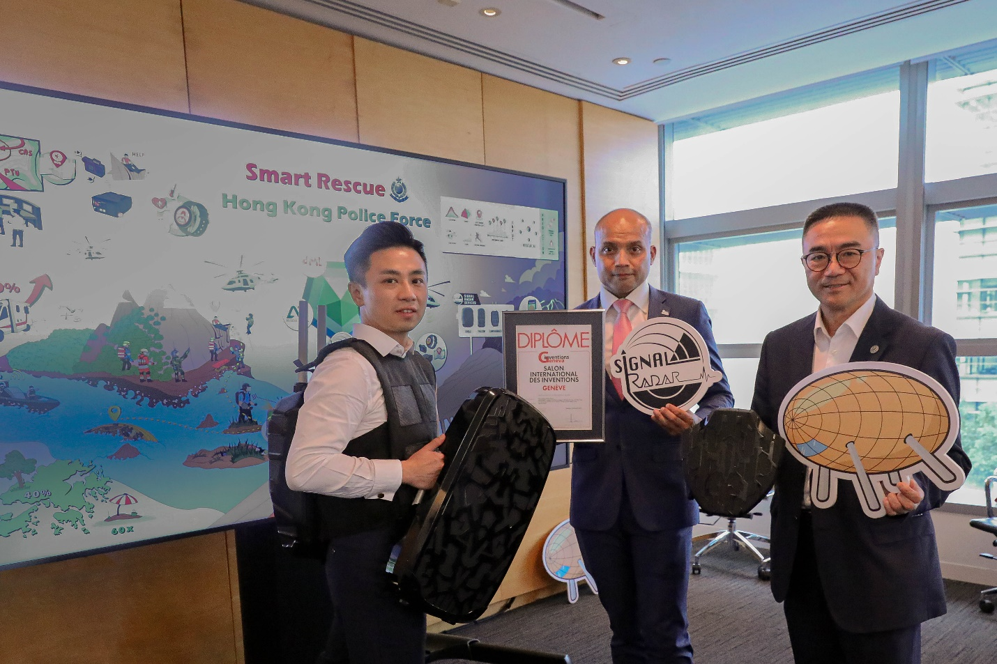
Photo 1: Eric Or, Head of Partnerships of Hong Kong Science and Technology Parks Corporation (right), MOHAMMED Swalikh, Senior Superintendent of Police from the Digital Policing Services Bureau of the HKPF (middle) and Ken Leung, Vice President of Business Development of Altai Technologies (right) showcase “Signal Radar” and Gold Medal award with the Congratulations of the Jury from the 48th International Exhibition of inventions of Geneva.

###

About Hong Kong Science and Technology Parks Corporation
Hong Kong Science and Technology Parks Corporation (HKSTP) has for over 20 years committed to building up Hong Kong as an international innovation and technology hub to propel success for local and global pioneers today and tomorrow. HKSTP has established a thriving I&T ecosystem that supported 14 unicorns and Hong Kong’s leading R&D hub with over 13,000 research professionals and over 1,400 technology companies focused on healthtech, AI and robotics, fintech and smart city technologies.

Established in 2001, we attract and nurture talent, accelerate and commercialise innovation and technology for entrepreneurs on their journey of growth in Hong Kong, to the Greater Bay Area, Asia and beyond. Our growing innovation ecosystem is built around our key locations of Hong Kong Science Park in Shatin, InnoCentre in Kowloon Tong and three modern INNOPARKs in Tai Po, Tseung Kwan O and Yuen Long. The three INNOPARKs are realising a vision of new industrialisation for Hong Kong. The goal is sectors like advanced manufacturing, electronics and biotechnology are being reimagined for a new generation of industry.
Through our infrastructure, services, expertise and network of partnerships, HKSTP will help establish innovation and technology as a pillar of growth for Hong Kong, while reinforcing Hong Kong’s international I&T hub status as a launchpad for global growth at the heart of the GBA innovation powerhouse.

More information about HKSTP is available at www.hkstp.org.

Media Contact:
Hong Kong Science and Technology Parks Corporation  Lisa Kao  Tel: +852 2629 7932  Email: lisa.kao@hkstp.org | Edelman Public Relations  Sonia Leung  Tel: +852 2837 4775  Email: Sonia.Leung@edelman.com/ Edelmanhkstppr@edelman.com

